PLOT 29, AWWAB MALL, ALBERT COOK ROAD, MENGO, KAMPALA www.him-ug.org

28th January 2016

REPORT ON THE BENET COMMUNITY RESETTLEMENT ISSUE.

Background
The Benet-Ndorobo people, who are indigenous inhabitants of some parts of the Mount Elgon forest have for the last 80 years struggled with a land problem with no end in sight. This wrangle arose in 1936 when the British colonial government gazetted all the Mt. Elgon forest area as a Crown forest without consulting the inhabitants of the forest. At that time, the Benet community occupying the forest was a small community whose basic livelihoods rotated around pastoralism, fruit-gathering, honey-harvesting and hunting.
Since the Mt. Elgon forest had been designated by the British colonialists as a soft-wood plantation area, the small population of the Benet community was used by the colonialists to clear the bushes in preparation for the plantations.
However, as time went on the Benet population in the forest grew, and their lifestyle changed. They abandoned pastoralism and started cultivation of crops like Irish potatoes and maize. By 1970, they started demanding for social services from government to enable their permanent settlement.
In 1983, the government of the day officially allocated land to the Benet community covering the areas between Rivers Kere and Kaptokwoi, stretching from the 1936 line in the north to the cliff line, which is now referred to as the Red line, where the beneficiaries of that land were awarded certificates of permanent residence.
The status of Mt. Elgon forest changed from a forest reserve to a national park in 1993, thereby bringing into disarray all the efforts that had been made to resettle the Benet community in the land they claim to be their ancestral land. Since 1993, there has been a harsh contest for land between the Benet community and the Uganda Wildlife Authority (UWA), the government agency responsible for nature conservation. In 2002, the Ugandan parliament passed a resolution allowing the adjustment of the national park boundaries to allow the resettlement of the Benet community. However, this resolution only catered for just a small part of the community, and left another part of the community landless, and vulnerable to eviction from the UWA.
Out of dissatisfaction arising from the manner in which their land issue had been handled by government, the Benet community, led by the Benet Lobby Group (BLG) and supported by the Uganda Land Alliance (ULA) filed a case No. 0001 of 2004 against the government of Uganda and UWA in the High Court, Mbale.
This Report is going to analyze the Consent Judgement of 27th October 2005 which arose as a result of this court suit, after a consensus had been reached between the Benet community, government and UWA. Other endeavors that have been undertaken to address the standoff, namely the Presidential directive of 2011 to resettle the Benet community and the recent statement by the president that government is to purchase land to resettle the Benet community, are going to be tackled to.
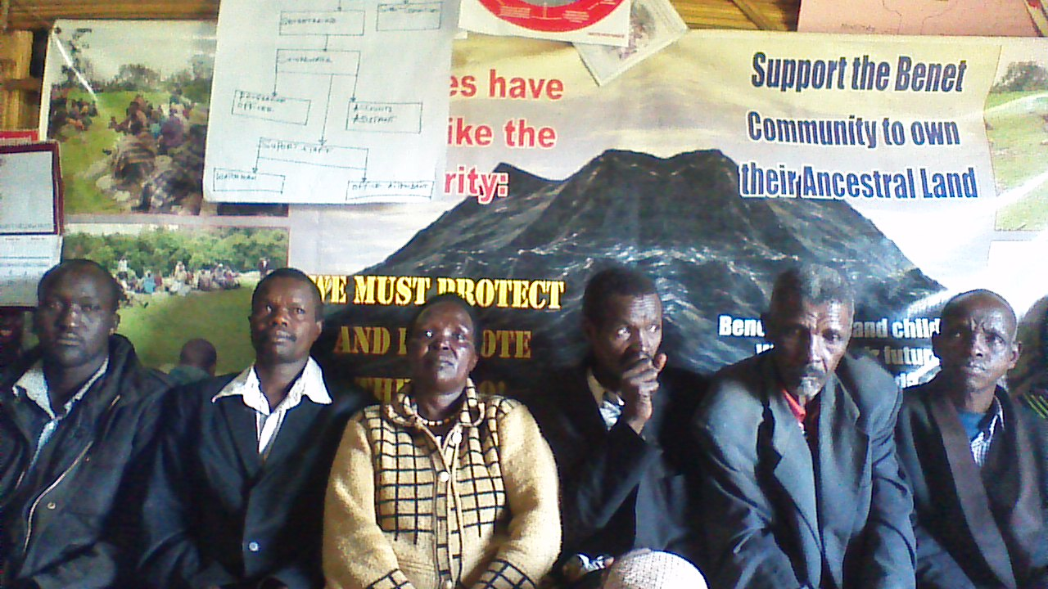
Pic. 1: Benet community members in their office.

- The Consent judgement
On 27th October 2005, three and a half months to the 2006 general elections, a consent judgement was reached between the three parties in the suit (Benet community, government of Uganda and UWA). The consent judgement and decree was agreed upon before Hon. Mr. Justice J. B. Katutsi in the presence of all the representatives of the three parties, and it was agreed that;
- The Benet community residing in Benet Sub-county including those residing in Yatui Parish and Kapsekek Village of Kween county and Kwoti Parish of Tingey county are historical and indigenous inhabitants of the said areas which were declared a National Park.
- The said community is entitled to stay in the said areas and carry out agricultural activities including developing the same undisturbed.
- The respondents (government of Uganda and UWA) take all steps necessary to de-gazette the said area as Wildlife protected area or National Park pursuant to the consent judgement, after a physical inspection of the boundaries with the Benet community.
- The second respondent (government of Uganda) takes affirmative action in favor of the said community to address the imbalance which presently exists in the said area in terms of education, infrastructure, health and social services in the spirit of Article 32(1) of the Constitution of Uganda, in lieu of general damages, commencing the Financial Year 2005/06.
- The respondents jointly and severally meet the applicant’s costs of the cause.
Though agreed upon by all parties to solve the land question in the Benet area, this consent judgement has largely remained on paper, and community members are today accusing government of lack of willingness to have it implemented. Despite this judgement, the land question in the Benet area has persisted and the tension is evident, with the community always on tenterhooks in the eyes of looming evictions and clashes with UWA which have led to loss of lives and property.
Several efforts have been made to remind government of its commitment to implement the consent judgement, but all have been in vain.
On 28th March 2007, the lawyer representing the Benet community wrote to the Attorney General’s office, asking them to implement the provisions of the consent judgement. “We shall be therefore be grateful if you can avail us an action plan on the steps that will be taken to implement the consent Decree,”a letter from Nangwala, Rezida and Co, Advocates reads.
Again on 18th April 2007, the same lawyer wrote to the Attorney General asking to be availed with an action plan on the steps that will be taken to implement the consent Decree.
On 5th July 2007, the lawyer once again wrote to the Attorney General, complaining about the non-response to his earlier letters, and threatening to go back to court for an order of mandamus if the office of the Attorney General does not avail him with an action plan to implement the consent Decree.
All these letters went unanswered. However, the lawyer never pushed through the threat of going back to court to get an order of mandamus.
Besides the efforts of the lawyers to get the Attorney General to ensure the implementation of the consent judgement on the government side, the Uganda Land Alliance (ULA), the agency that was instrumental in assisting the Benet community to bring its case before court, was also engaging different players in government namely the Ministry of Trade and Industry under which the tourism docket and the Uganda wildlife Authority fell, to find a way of implementing the consent judgement, thus resolve the resettlement issue of the Benet community.
On 17th December 2007, ULA wrote to the then Minister of State for Tourism, Wildlife and Antiquities Mr. Serapio Rukundo informing him about the need to resolve the Benet resettlement issue, and in his response to ULA on 8th February 2010, Mr. Rukundo raised issues that were standing in the way of implementing the consent judgement, namely the identification of the genuinely displaced landless communities to justify the identification of land by government to resettle them. However, this is mentioned nowhere in the consent judgement.
To make matters worse, the Minister for General Duties in the Office of the Prime Minister Hon. Tarsis Kabwegyere wrote a letter on 17th April 2014 to the area Resident District Commissioners (RDC’s) asking them to make preparations for the eviction of the Benet community. The Minister also asked all local leaders to ensure that the eviction is carried out smoothly.
This action prompted a letter from the Benet legal representative, Mr. Max Mutabingwa, on 3rd November 2014, where he wrote to the Minister of General Duties in the Prime Minister’s office informing him, among others, the consent judgement that had remained unimplemented up to that date. The looming eviction was stayed pending further negotiations because the Benet community was ready to die defending their land than be evicted by government.
Mr. Max Mutabingwa wrote again to the Attorney General on 6th March 2015, informing him about the delay in executing and implementing the consent judgement. The lawyer threatened to take government back to court if the consent judgement is not adhered to. Todate, no progress has been made in as far as the implementation of the consent judgement is concerned, and no legal action has been taken against government for failing to adhere to the consent judgement.
Hub for Investigative Media (HIM) together with Actionaid organized a validation meeting with the Benet community members on 22nd January 2016 in Benet Sub-county, Kween district, where the Benet Lobby Group (BLG) and other community members aired out there views about the consent judgement and government’s willingness to implement it.
Julius Chemayek and Stephen Chemungwa, both Benet Lobby Group members, are in unison that the government neither implemented nor shown any interest to implement the consent judgement.
Geoffrey Matui, a Benet Lobby Group board member said that despite its deficiencies, the presence of the consent judgement has been very crucial because if it was not there, the community would have already been evicted from the areas. “We need assistance to follow up the consent judgement and have it implemented to its logical conclusion,” he added.
On the other hand, Irene Kaperwa, who took part in the court case in 2005 and is currently a support member at the Benet Lobby Group, said that she is worried because of the continued failure or refusal of government to provide the Benet community with social services. “It seems that they (government) have already made up their mind to evict us from our land, that is why they do not find it necessary to provide us with social services,” she noted. She also pointed out that the adjustment of the boundaries, as was agreed upon in the consent judgement, has not been done too which reflects government’s unwillingness to have the community’s stay on their land legalized.
Another Benet community elder, Matayo Twindai, compounded the community’s disgust and loss of hope in government and the willingness to have the consent judgement implemented, saying that the situation is like there is no government to protect the Benet community and that “Actionaid is like our government now.” He further stated that government always comes out towards election time and makes promises to have the Benet land issue solved, but after elections, nothing is done to have the problem fixed.
(N.B: The consent judgement was arrived at on 27th October 2005, three and a half months to the 2006 presidential and general elections)
Matayo Cherotich, a Benet Community member also reiterated that the Benet people have totally lost trust in the government’s ability to have the land issue settled amicably as stated in the consent judgement, therefore they appeal to Actionaid to assist them go back to court and have the consent judgement implemented other than relying on government’s promises.
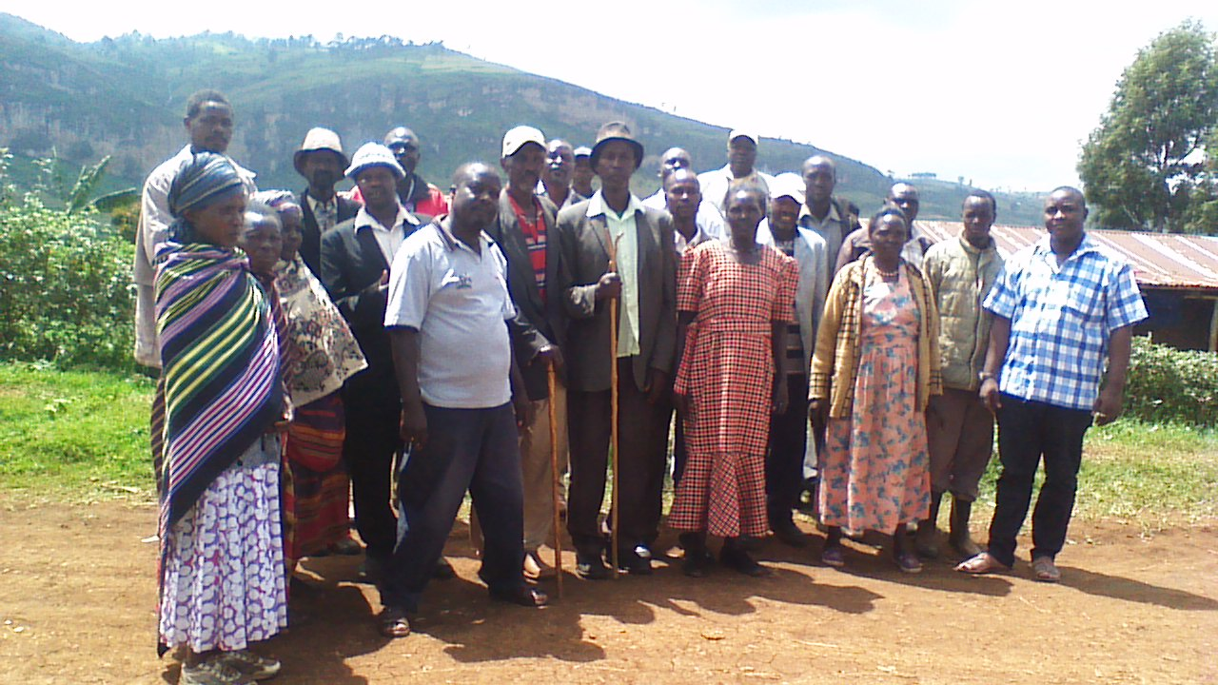
Pic. 2: Mr. Peter Kalule (extreme right), the Actionaid Coordinator on the Benet land issue, poses for a group photo with Benet community members after a validation meeting held on 22nd January 2016. In the background is part of Mt. Elgon.

- The Presidential directive on the Benet land issue
In his letter of 5th February 2011, thirteen days to the 2011 presidential elections, President Museveni wrote a directive No. P.O/3 to the Prime Minister. The President directed him to expeditiously resettle the landless Benet people in the London area of Mt. Elgon.
In his hard-hitting letter, the President directed the Prime Minister to de-gazette the London portion of the Forest National Park so that the landless Benet people can be resettled permanently. He further directed that those people be given building materials such as cement, iron-sheets and construction bricks so that they can build permanent homes as a compensation for their prolonged suffering since their displacement.
The President went on to direct that the NAADS programme should avail them with seeds and other planting materials together with improved livestock breeds to ensure their sustainable livelihood and economic emancipation from subsistence farming. He also directed the national park authorities to examine the request of the landless families to be allowed to graze their cattle in the grasslands of the National Park.
The Presidential directive highly raised the hopes of the Benet people thinking that this would be the end to the long-term problem they had had, especially so because the President had indicated that the directive should be implemented immediately. However, the provisions of this presidential directive never saw the light of day.
Over a year after the presidential directive on 27th August 2012, the then Minister for Security and the Presidency Mr. Muruli Mukasa wrote a letter to the Prime Minister, informing him of reports of mistreatment of the landless Benet people by UWA officials, despite the presidential directive. “The purpose of this letter is to draw your attention to His Excellency’s directive for action,” the Minister concluded his letter to the Prime Minister.
On 10th May 2013, the chairman of the Benet Lobby Group Mr. Francis Sabila also wrote to the Minister in Charge of the Presidency following up on the unimplemented presidential directive, requesting him to fast-track the implementation process to solve the Benet land issue once and for all.
However, all these efforts to have the presidential directive implemented were in vain.
It was learnt that later on following the presidential directive, the Head of Public Service constituted an inter-ministerial technical team to work on the modalities of implementing the directive. A nine-member team comprising of officials from the ministries of Water and Environment, Tourism, Trade and Industry, National Environment Management Authority and Office of the Prime Minister was constituted and visited the London area which was supposed to be de-gazetted as provided in the presidential directive.
The team concluded that de-gazetting the London area would in the medium to long term severely affect the ecosystems of many parts of Mt. Elgon, the wetland systems of Teso sub-region, the water in-flows into Lake Kyoga, among other ecosystems. The team concluded that if de-gazetted, there was risk of increased landslides in the area, risk of water shortages, and increase of soil erosion among other environmental hazards. It was against this background that the inter-ministerial team strongly recommended that the London area should not be de-gazetted, and suggested that alternative places for the resettlement of the Benet people should be identified.
In his report dated 24th February 2015 responding to issues raised by the committee on presidential affairs on resettlement of the landless Benet in Sebei sub-region, the minister for General Duties in the Office of the Prime Minister Prof. Tarsis Kabwegyere stated that NEMA and UWA have technically advised against any further de-gazettement of any part of Mt. Elgon, claiming that increasing human activity in the park would result into adverse environmental impacts.
This clearly indicates that government has no plans whatsoever to implement the presidential directive; even the rhetoric from the president himself has changed. He is no longer talking about the directive that he asked the Prime Minister to implement. Instead, he is talking about finding alternative land to resettle the landless Benet community in that area. The change in presidential rhetoric technically puts the implementation of the 5th February 2011 presidential directive off the table.
Speaking about the presidential directive, Joseph Kapchumo, a Benet elder with three wives and 30 children said that “that directive was nothing but a pack of lies to us.” He goes on that the Benet community has for long been lied to by the President through false promises, while UWA continues to torture and kill members of the Benet community.
(N.B: A community member, Chelangat Stephen, was killed by UWA; the President tasked the Inspector General of Police General Kale Kayihura to investigate the matter, but no report has come out years after this incident)
The community members were all in unison that they have lost trust in the presidential directive, and they have no hope that their land issue can be solved through those directives.
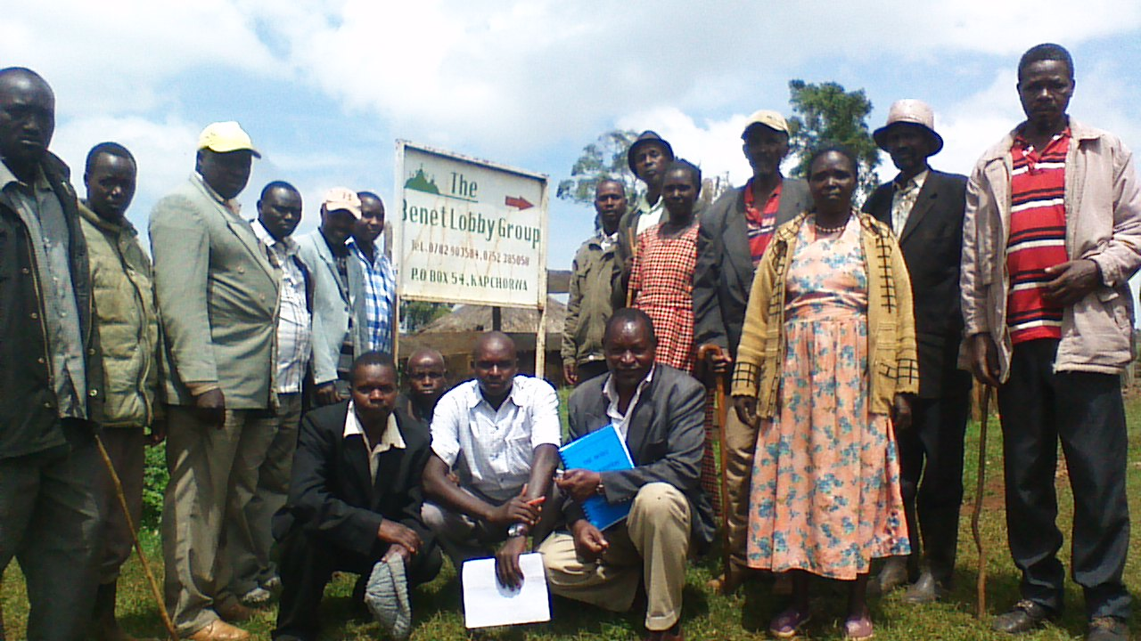
Pic. 3: Benet community members pose for a photo near their offices.
- Indentifying alternative land to resettle the Benet
While on his campaign trail in Kapchorwa four weeks ago, which was about nine weeks to the 2016 presidential elections, President Museveni told the people that government is in the process of identifying land to resettle the landless Benet community. He said that 9 billion Uganda shillings has been set aside to procure the land. It is alleged that after making this statement, many people abandoned the presidential rally in a show of disappointment to the presidential statement.
William Cheptegei, a Benet community leader said that the Benet people are against being moved from their land.”We are used to living in the high altitudes in the mountains where our ancestors and we have lived since time immemorial. Now they want to take us to the lower areas of Bulambuli and other areas; we cannot survive there. This is like taking fish out of the water and expecting it to survive,” he asserted.
Community members further asserted that they are the rightful owners of that land, and their numbers have now grown up to over 20,000 people therefore they are not ready to be resettled anywhere else apart from their ancestral land.
The recent events in the area have not made the situation any better. When the opposition candidate Kizza Besigye visited the district on his campaign trail, the police fired bullets and several people were injured as the police tried to refrain Besigye from visiting an IDP camp, where people who were evicted from their land in the Mt. Elgon areas are now living since 1998.
That incident has increased fear and anxiety among the communities, forcing the Inspector General of Police to set camp in the area to calm the situation. On top of that, the District Police Commander who authorized the policemen to fire live ammunition in an attempt to stop Besigye from accessing the IDP camp has been fired by the police chief.
Speaking about the president’s idea of purchasing land to resettle them, Matayo Cherotich said that he was deeply disappointed and demoralized by the president for turning against his own word (the directive). “I was born here and all my children have been born here, and I will not accept to be moved to any other area,” he said. He added that the land that the president wants them to resettle on is owned by people who ran away from it because of the Karimojong cattle rustlers, and as peace returns to those areas, the owners of that land are slowly coming back to repossess their land. “Just imagine the chaos that will prevail if those people come back and find us resettled on their land. That will be war, an even bigger problem than we are having now,” Cherotich asserted.
Observation
During the interactions with the affected communities, it came out clearly that government has not been so forthcoming in showing political will to have the land issue solved once and for all.
It was also observed that some steps that have been taken to resolve the matter have come at a time of general elections, for example in 2005, in 2011 and recently towards the end of 2015. There is a general feeling among the affected communities that government only comes out with possible solutions to the land problem during election seasons, and after elections, all efforts to resolve the matter are forgotten.
Recommendation
From what has been gathered from the Benet community members and their leaders, it has been found that many promises have been made to them by government, but none of them has been implemented to find a lasting solution to the land question.
It is however advantageous that there is already a consent judgement of 27th October 2005 in place which, among others, recognizes and declares that the Benet community is entitled to stay in their areas undisturbed. This is the only legally binding tool that is at the disposal of the Benet community to find a lasting solution to their problem.
It is therefore highly recommended that all available means are deployed to put this powerful tool to its intended use; the consent judgement has got to be enforced to provide justice to the Benet community.
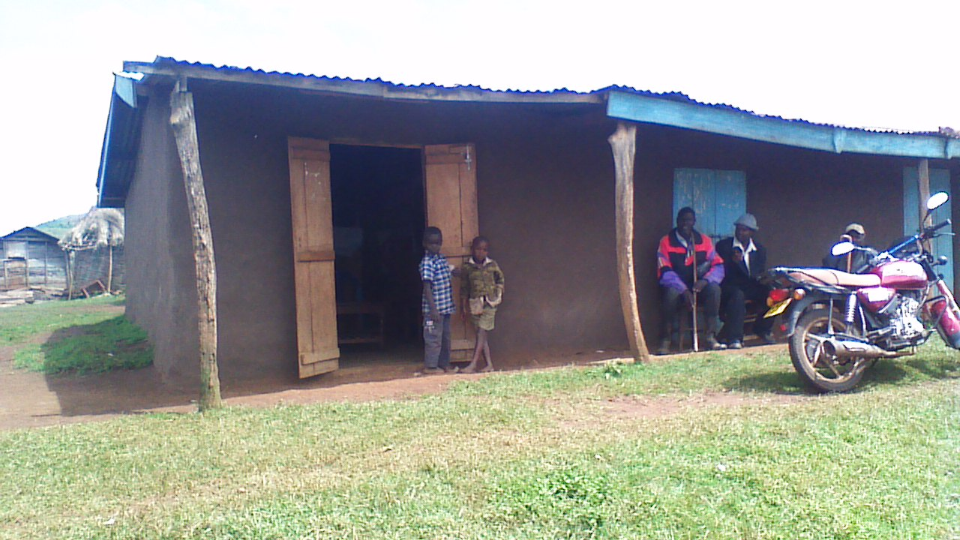
Pic. 4: The Benet Lobby Group offices.

Conclusion
Throughout the consultations we have had with the Benet community members and their leaders, it is evident that they have all lost hope in the promises of government to resettle them and the piecemeal actions of the authorities to find a lasting solution to the land question in their area.
The community members have all agreed that neither the presidential directives nor the recent promises by the president will or can produce a lasting solution to the land issue at hand, that can lead to their permanent resettlement.
It is against that background that the Benet community members and their leaders want the implementation of the consent judgement of 27th October 2005 as the last legally binding solution to their permanent settlement. This consent judgement has been in place long enough, but has not been adhered to by the responsible government authorities, which has not only prolonged the suffering of the Benet community in their quest for permanent resettlement but also created a situation of contempt of court in the search for justice for the Benet community, especially on the side of those government entities that were ordered by court to implement the consent judgement.
During our last consultation with the Benet community members and their leaders on 22nd January 2016, they all requested for support from organizations, especially Actionaid, to have the consent judgement implemented. “That is our last hope,” a Benet community leader William Cheptegei said.

Edward Ronald Sekyewa,
Executive Director, Hub for Investigative Media (HIM)
Tel: 0775-185-598
Email: edwardronalds16@gmail.com
Website: www.him-ug.org

